Bowen Community Broadcasting Assoc. Inc.
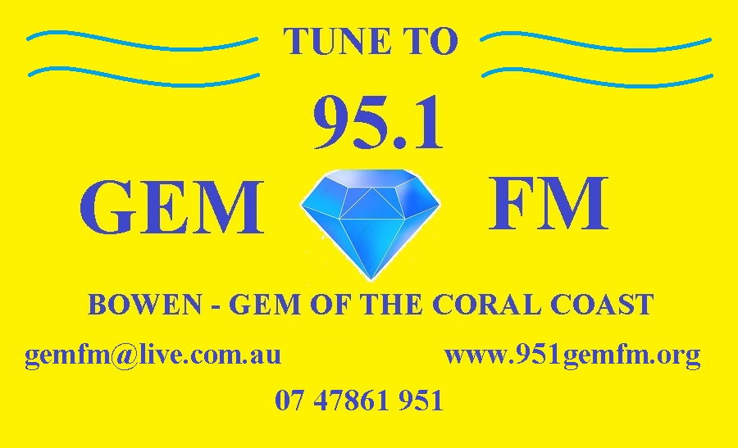
T/A Gem FM

Phone : 0408 739 321
BOWEN QLD 4805

MEMBERSHIP FORM

I would like to become a member of
95.1 Gem FM –Bowen’s own Radio Station

Contact Name:
Signed:
Address:
Phone:
E-Mail:

YEARLY MEMBERSHIP FEES

Private Members
Individual $20.00
Includes Membership Benefits
Full Voting Rights

Please scan and send this form to gem@live.com.au or print and send completed form
to:-“The Secretary”
PO BOX 122
Bowen 4805
Do not send money or cheques with this form, you will be invoiced and supplied with
95.1 GEM FM’s banking details. Thank You.

www.951gemfm.com.au

